HVAC SYSTEM DESIGN
Student’s Name
Institution Affiliation
Date of Submission

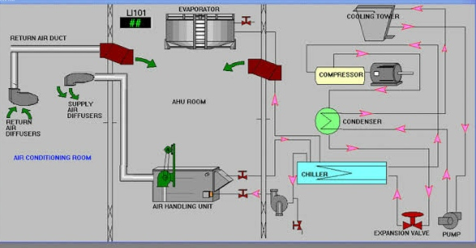

The HVAC frameworks have been measured and chosen. The last (and most tedious) part of the general cycle is the genuine plan of the HVAC frameworks. This stage includes finding the hardware, coordination with other plan experts, measuring and designing the ventilation work and funneling, indicating the entirety of the hardware and materials, characterizing the HVAC controls, and – the last result of the HVAC plan – setting up the drawings and details. At the beginning of this cycle, some viewpoint is altogether as to the eventual outcome. The drawings and determinations are the perfections of the plan exertion, and they, by and large, serve at least five purposes:
- The drawings give the customer a way to audit and consent to the proposed plan before assembling.
- The drawings serve to archive that the entirety of the relevant building regulations has been followed. The drawings are marked and fixed by the expert architect in mindful charge of the plan. The person in question should be enrolled in the state where the development will happen. The drawings are then submitted for endorsement to the Building Department, where the venture is found. When supported, a structure license will be given to approve the beginning of development.
- Workers for hire utilize the drawings to offer on the task, and normally the most minimal bidder is chosen to develop the task.
- The principal reason for the drawings is their utilization by the worker for hire to fabricate the task.
- After development is finished, the drawings fill in as a record of what was assembled, which can be utilized sometime in the not too distant future if the structure is to be redesigned or extended.
As a piece of the planning cycle, all relevant building regulations should be surveyed to guarantee that the proposed configuration is code-agreeable. A call to the Building Department or a visit to the city's site will help figure out which codes are upheld. A large portion of the necessities relating to HVAC is found in the Mechanical Code. Notwithstanding, extra HVAC-related prerequisites can be found in different segments, including the Energy Code, the Plumbing Code, the Architectural Construction law, the Fuel Gas Code, and the Electrical Code.
The ideal worth or set point is changed at the handle on the facade of the indoor regulator. (Note that the indoor room regulator contains the sensor, set point change, correlation gadget, and the regulator, shown particularly in the square outline above). The temperature sensor gauges the real esteem and conveys a message back along the input way to the examination gadget. The correlation gadget analyzes the worth of temperature at the sensor to that of the ideal worth or set point on the regulator. The distinction between ideal worth and deliberate worth is known as the blunder signal. The mistake signal is taken care of into the regulator as a low voltage signal (10 volts) to the actuator. The cool gadget, an actuator on a 2-port valve, responds to the drive from the regulator and fluctuates the progression of the high temp water. It thusly changes the state of the space or cycles to the ideal worth. This sort of control is called regulated control because the control components are continually changing the sign from the examination gadget to keep a close to the steady temperature in the room even though inside and outside conditions may differ. The commonplace designer regulates a task beginning to end and afterward sells or rents the created property for a benefit. The individual who purchases many lands gets the fundamental subsidizing, and public endorsements to develop a structure there, utilizes a planning group, and recruits a worker for hire to construct it. Engineers commonly acquire huge measures of cash for their turns of events, so they need to get the structure finished as fast and as economically as could be expected. Thus, normally the most significant thing to a designer is the first expense (hardware cost). Huge assembling organizations and college frameworks are two instances of the proprietor kind of customer. A proprietor constructs an office and needs to live with it however long it stays standing. Thus, proprietors are worried about the complete expense, i.e., energy productivity, simplicity of upkeep, life span, just as the first expense.
The size of a task is another vital part to consider while picking an HVAC framework. More modest activities loan themselves to DX frameworks because of the lower first expenses and simplicity of upkeep. As the undertaking size expansions in cooling limit more than 100 tons, the energy-saving advantages of a chilled water framework start to exceed the principal cost and upkeep reserve funds related to DX frameworks. In the 100 – 250 ton range, air-cooled chillers are usually utilized. Energy investment funds in projects more than 250 tons regularly legitimize the additional expense of a water-cooled framework. Water-cooled frameworks require more complex upkeep for the related siphons, cooling towers, water treatment, and refrigerant administration. A few activities are a bad contender for water-cooled chillers, paying little heed to the task size. One model may be an undertaking where there is nothing but a bad spot to find the cooling tower. Cooling towers are uproarious, and they produce fog (float). Only one out of every odd venture can oblige that. Another model may an exceptionally segregated area. Such an office probably won't approach an upkeep organization willing to travel that far, and recruiting lasting support workers would result in an incredible arrangement of inactive time. Circumstances like these are the place where great designing judgment comes into play. The sort of venture additionally has a critical bearing on the determination of the HVAC framework. The Central air framework for a place of business will regularly be not the same as the HVAC framework for a retail store, which will be not quite the same as the HVAC framework for a distribution center. Places of business require a serious level of individual tenant solace and accordingly are quite often planned with VAV frameworks. Alternately, in a major box retail location, consistent volume frameworks are a decent application since the enormous, open stores have a similar warm stacking all through. Assembling plants accept applications for evaporative cooling frameworks because while a fabricating plant needs some level of cooling, completely cooling such offices may not.

